



**One step at a time**

What is a Personal Statement?

* Whether you are applying for a further education course, a degree course at university or a job, you will be expected to complete a section of the application process called the ‘**Personal Statement’.**
* This sometimes appears as a free text box at the end of the application forms. It is your chance to say why you think you should be accepted onto the course and supports your application..

**It is useful to have a Personal Statement ready in advance**

* It can also be the most daunting part of completing an application form!
* You WILL need to know what course(s) you are applying for BEFORE completing your statement.

**Writing a personal statement will take some time. However it is helpful to break it down into manageable chunks.**

* **Use each questions to help structure your paragraphs and draft your personal statement.**
* **Type up each section as you go along and you will soon have a completed statement**

1. **Drafting your Personal Statement**

**Get some words down on paper to get you started**

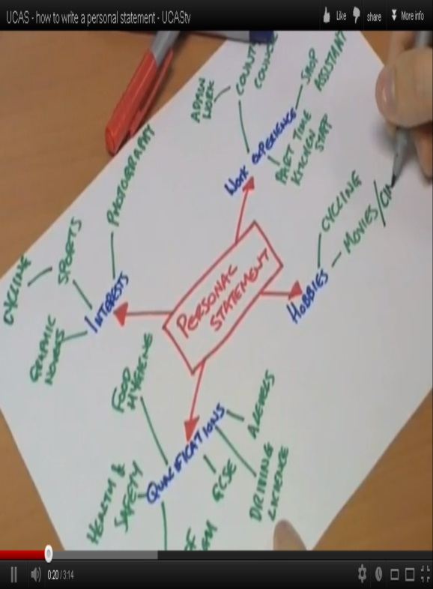

**Brainstorm your achievements, work experience, interests, skills, qualities and any other experiences you have had or projects and activities in which you’ve been involved.**

[](http://www.google.co.uk/url?sa=i&rct=j&q=time&source=images&cd=&cad=rja&uact=8&docid=3mX_wzBFhqmWSM&tbnid=Xx_NcjwzJyKIfM:&ved=0CAcQjRw&url=http://www.4castplus.com/time-phased-budgeting-who-needs-time-phased-budgeting/&ei=IFEyVPS6H9DcaNe5gPgH&bvm=bv.76802529,d.d2s&psig=AFQjCNHhYSTgKfXrkQYegqoVdovG_bUNMA&ust=1412669992427082)**Personal Statement**

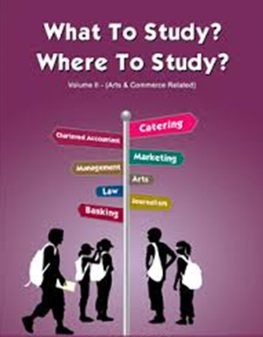

[](http://www.google.co.uk/url?sa=i&rct=j&q=college%20courses&source=images&cd=&cad=rja&uact=8&docid=FINd9fVmY53ejM&tbnid=fSpRPwXX70jHiM:&ved=0CAcQjRw&url=http://online.dpsk12.org/2013/02/16/take-college-classes-next-fall/&ei=mG0yVMXEFI2xPOS9gagH&bvm=bv.76802529,d.ZGU&psig=AFQjCNFuw19cX_hP4n0Tz3bPOXXq9xBsJQ&ust=1412677385107332)

[](http://www.google.co.uk/url?sa=i&rct=j&q=apprenticeship&source=images&cd=&cad=rja&uact=8&docid=DpotfAYTPw8b-M&tbnid=3QcvIfXGlTuT2M:&ved=0CAcQjRw&url=http://orangejuicepr.co.uk/?p%3D715&ei=2G0yVLONKsbWPZWVgJAC&bvm=bv.76802529,d.ZGU&psig=AFQjCNFU_WuTnRtStSW6ymAWxOzFfBHBhQ&ust=1412677438679931)

**If you haven’t decided which course(s) you want to pursue yet, just move onto the other sections and come back to the first section at a later date.**

**1. What subjects do you enjoy currently and what subjects would you like to study at College. Is there a specific reason you want to apply for the course(s) ?**

|  |
| --- |
|  |

|  |
| --- |
| ***For example: I am currently in Year 11 at Smithills School. I have a particular interest in Art and Business. I have researched the options and routes available to me in pursuing these areas of study and would be very interested in studying for A Levels in Art & Business so that I can pursue a possible career in Marketing in the future. I spent my work experience in the marketing department of a local company and really enjoyed using my creative skills.*** |

**2. Tell me about YOU- include some of the following;**

* [](http://www.google.co.uk/url?sa=i&rct=j&q=knowledge%20and%20skills&source=images&cd=&cad=rja&uact=8&docid=rdjFrTASDytWTM&tbnid=7XMsvaEWHmh_sM:&ved=0CAcQjRw&url=http://freedomoutpost.com/2013/11/thing-skills-hands-knowledge-mind/&ei=QlYyVMqVBtfvatGCgrgH&bvm=bv.76802529,d.d2s&psig=AFQjCNGwHCy9h4B2hQtNwaVKGx5jMM2SCQ&ust=1412671398894194)Involvement in extracurricular activities and clubs / community / sports teams/ performing arts etc.
* What skills I have
* Any positions of responsibility
* Any hobbies and interests outside of school.
* Proud moments: achievements/awards
* Additional qualifications being studied or completed.
* Work experience

|  |
| --- |
|  |

***For example:***

|  |
| --- |
| ***I enjoy creative writing and debating different topics. I have been involved in Mock trials and represented Smithills in a regional competition presenting a case for the defence. I have been part of the school council where I have listened to my peers and represented them at meetings. I also enjoy solving problems and was part of the enterprise game challenge last year learning about business and how to take risk to generate profits. I am proud to be a peer mentor in school and supported younger pupils through difficult times. I have 100 % attendance certificates. I have recently been involved in the stalls in the hall enterprise challenge at school which helped raise money this year for the charity ‘Make Kyle Smile’***  ***Example 2***  ***I am involved in the Duke of Edinburgh Award scheme which has allowed me to develop leadership skills, self-discipline and teamwork. I have also been able to use my organisational skills as a helper at Bolton Lads and Girls Club and organise games and activities. I have completed a marketing project as part of my business studies course so understand how best to maximise sales. I have represented the school in an Enterprise challenge competition which required us to purchase stock and sell to maximise profits whilst also gaining distribution centres to improve the number of sales. I have taken on additional roles in school including being a sports leader which has enabled me to demonstrate that I can be responsible for others and take the lead in specific situations. I attend a local gym which helps me develop my fitness.*** |

[](http://www.google.co.uk/url?sa=i&rct=j&q=my%20future&source=images&cd=&cad=rja&uact=8&docid=iD9CSBkyMjvgfM&tbnid=HZvZPhonWxeElM:&ved=0CAcQjRw&url=http://borderlinebloggeren.blogspot.com/2012_09_01_archive.html&ei=-FwyVO65MYT7PP-ogbgF&bvm=bv.76802529,d.d2s&psig=AFQjCNGVll_gCP0wKdIdbSkkNZfghG1NsA&ust=1412672983547377)

**3. What I want to do after college. Long term aspirations –University/ Apprenticeship/ Employment.**

|  |
| --- |
|  |

|  |
| --- |
| ***I would very much like to remain in full time education and eventually go to university.***  ***I would love to pursue a career that permitted me to be creative and travel.***  ***Or***  ***I would very much like to pursue an apprenticeship route in the future and gain employment with one of the major companies in my chosen field.***  ***Or***  ***After completing my studies at college I would like to become employed as a….*** |

***For example:***

Before submitting your application

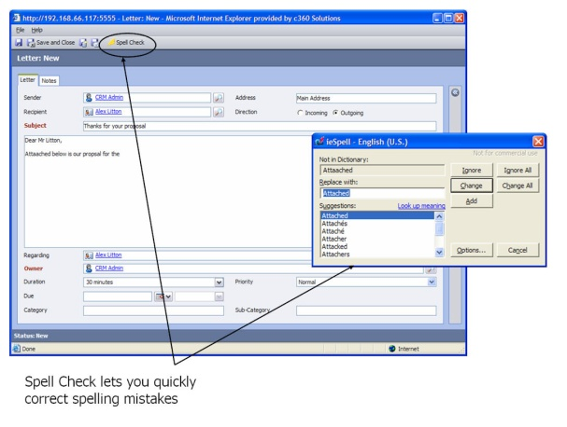

Check it!

Make sure;

* It is written in good, concise English
* There are no grammatical and spelling errors.

It is not copied as this could jeopardise your applications to college.

[](http://www.google.co.uk/url?sa=i&rct=j&q=top+tip&source=images&cd=&cad=rja&uact=8&docid=eGJl2StPbnZZgM&tbnid=8gb_4AEBo5uufM:&ved=0CAcQjRw&url=http://www.whodoyouthinkyouaremagazine.com/next-steps/ancestors-overseas&ei=FmcyVMf9H4nGPeCTgHA&bvm=bv.76802529,d.ZGU&psig=AFQjCNEASG-DoBQdVJECqXVpOfB3bbjwPA&ust=1412675687236383) Make sure you have the course content and entry requirements to hand so you can refer to them as you are preparing your personal statement.



IF you make a new application and you have **applied for a different course** or a number of subject areas, your reasons for wanting to study the course/subjects would be different. **Save a new version after making the changes.**