Year 11

Name: Form:

|  |
| --- |
| Supporting your Post 16 Transition | 2022-23 |

[](http://www.google.co.uk/url?sa=i&rct=j&q=&esrc=s&source=images&cd=&cad=rja&uact=8&ved=0CAcQjRw&url=http://scqf.org.uk/education-providers-advisers/schools/my-skills-my-future/&ei=eBOVVa3uDPGy7Qbkn6DgAg&bvm=bv.96952980,d.ZGU&psig=AFQjCNHDB2sdLjuRAjfligLPTWegMw465Q&ust=1435918812298168)

|  |  |
| --- | --- |
| **Session 0** | **Post 16 progression** |

**Introduction**

**This booklet is intended for use throughout Year 11 and should be kept safe and used as a point of reference to support you as you move through your final year.**

**You will be asked to make important decisions about your future and you will shortly be submitting applications for further education and/or training.**

**So What’s Next**

**How do you see your future mapped out?**

**Which direction do you think you might take through each stage?**

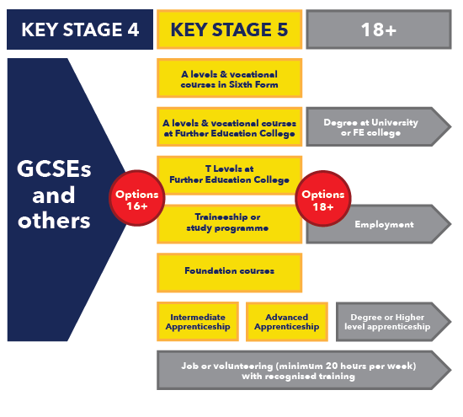

**Use the Checklist below to plan what needs to be done and make sure you are on track to complete and submit your post 16 applications and make your transition as smooth and as successful as possible.**

**CHECKLIST**

|  |  |  |
| --- | --- | --- |
| **Dates** | **To Do List** | **Completed** |
| **April 2022- September 2023** | * **Make sure you know what post 16 opportunities are available to you.** * **Visit the careers website and access the links to all the Post 16 providers available locally and beyond**   <https://www.smithillscareers.com/>   * **Look through prospectuses or use individual post 16 provider websites to explore subjects/courses, qualifications and levels of study that you would like to access post 16.** |  |
| **September 2022** | * **SEARCH for suitable Post 16 organisations of real interest to you to pursue your post 16 studies.** * **Explore Apprenticeships as an alternative Pathway** |  |
| **September 2022** | **Look through individual prospectuses to see the types of courses, subjects and qualifications needed for future study.** |  |
| **Sept- December 2022** | **Attend College Open Evenings for all those you are interested in applying to for future study** |  |
| **October- December 2022** | **Visit specific college websites and complete ONLINE or paper applications** |  |
| **Before end of December 2022** | **Submit your ONLINE Application(s) to your preferred college(s) or training provider(s)** |  |
| **AS REQUESTED** | **Respond to text messages or emails to book interviews with those providers you have applied to.** |  |
| **December 2022– March 2023** | **Attend admissions interviews as requested** |  |
| **January – March 2023** | **Accept Providers conditional offer (for all those you are still seriously considering studying at after leaving Smithills.** |  |
| **March onwards**  **For those making APPRENTICESHIP applications** | **Made sure your CV is up to date and you are actively seeking an employer**   * **Use the National Apprenticeships website (https://www.gov.uk/apply-apprenticeship)** * **Local college vacancies on their own websites e.g. Bolton/Bury** * **Training provider websites will post vacancies** * **Search individual company websites** * **Check the Careers noticeboard for current VACANCIES** |  |
| **JULY 2023** | **Attend new student days as requested for the organisation you intend studying with in September 2023** |  |
| **August 2023** | **Collect results from Smithills School and go to ENROL with the college or training provider you have decided to study with from September 2023** |  |

[](http://www.google.co.uk/url?sa=i&rct=j&q=time&source=images&cd=&cad=rja&uact=8&docid=j1dlUSbOBqzLZM&tbnid=hkjhpEeXe-1alM:&ved=0CAUQjRw&url=http://yogavpk.com/ayurveda/why-time-doesnt-fly-and-how-you-can-slow-it-down/&ei=gMoGVIjCIqO80QX5woCoDQ&bvm=bv.74115972,d.d2s&psig=AFQjCNGroT1Sgpc-SV3x6w3-YuCFe7FAXA&ust=1409817554392477)

**INVEST in YOUR Future**

**Make time to research what you would like to do in the future. This will help you make important decisions about what subjects you may NEED to study to be able to pursue your chosen career**

**USE the following ONLINE Careers Resources**

**All the information and tools you need to explore your future career**

[](https://careerpilot.org.uk/)

Career Pilot <https://careerpilot.org.uk/>

Start is an online resources that enables students to match personal skills, interests, qualities and work preferences to see if they would be well matched to specific careers. It enable students to explore career sectors and jobs in depth

**Login using your school email for both START login and START password**

<https://gmacs.co.uk/career-plan>



SIGN IN to Xello using your UNIQUE LOGIN

**SMITH-XXXXXXX (School login)**

Password (MMDDYYYY)



<https://nationalcareersservice.direct.gov.uk>

This website provides careers advice and information on a wide range of jobs and training resources.

[](http://www.google.co.uk/url?sa=i&rct=j&q=&esrc=s&source=images&cd=&cad=rja&uact=8&ved=0ahUKEwj0_czSnrbNAhWDBsAKHQ65DY4QjRwIBw&url=http://www.fairtrain.org/&psig=AFQjCNHXrbRcD-FBWejd7t_Lv3jrmG70qg&ust=1466499529525559)

<https://www.apprenticeships.gov.uk/>

View apprenticeships opportunities at all levels to see what is available then create a new user account so that you can make an on line application. Make sure you have created a CV in advance so that you can upload this as requested. (Note: you will need to ‘update’ this regularly to make sure it is relevant to the post for which you are applying)



<https://www.ucas.com/>

This is the universities website which is useful to use for researching whether there are any specific subjects that MUST be studied to pursue the degree courses at university. It will also show students the grades that they will be expected to achieve after studying Level 3 qualifications (A-levels, Btec, T Levels ) to pursue degree courses at University.

This can help students make choices about the subjects they want or need to pursue at College or Sixth Form.

List of Russell Group Universities

<https://russellgroup.ac.uk/about/our-universities>

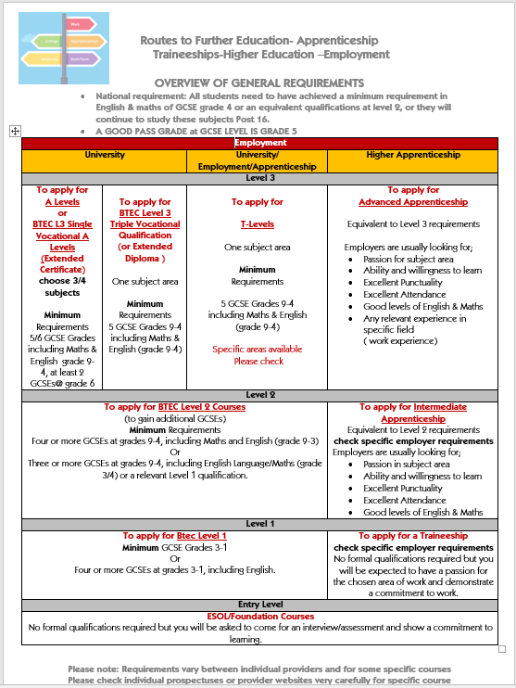

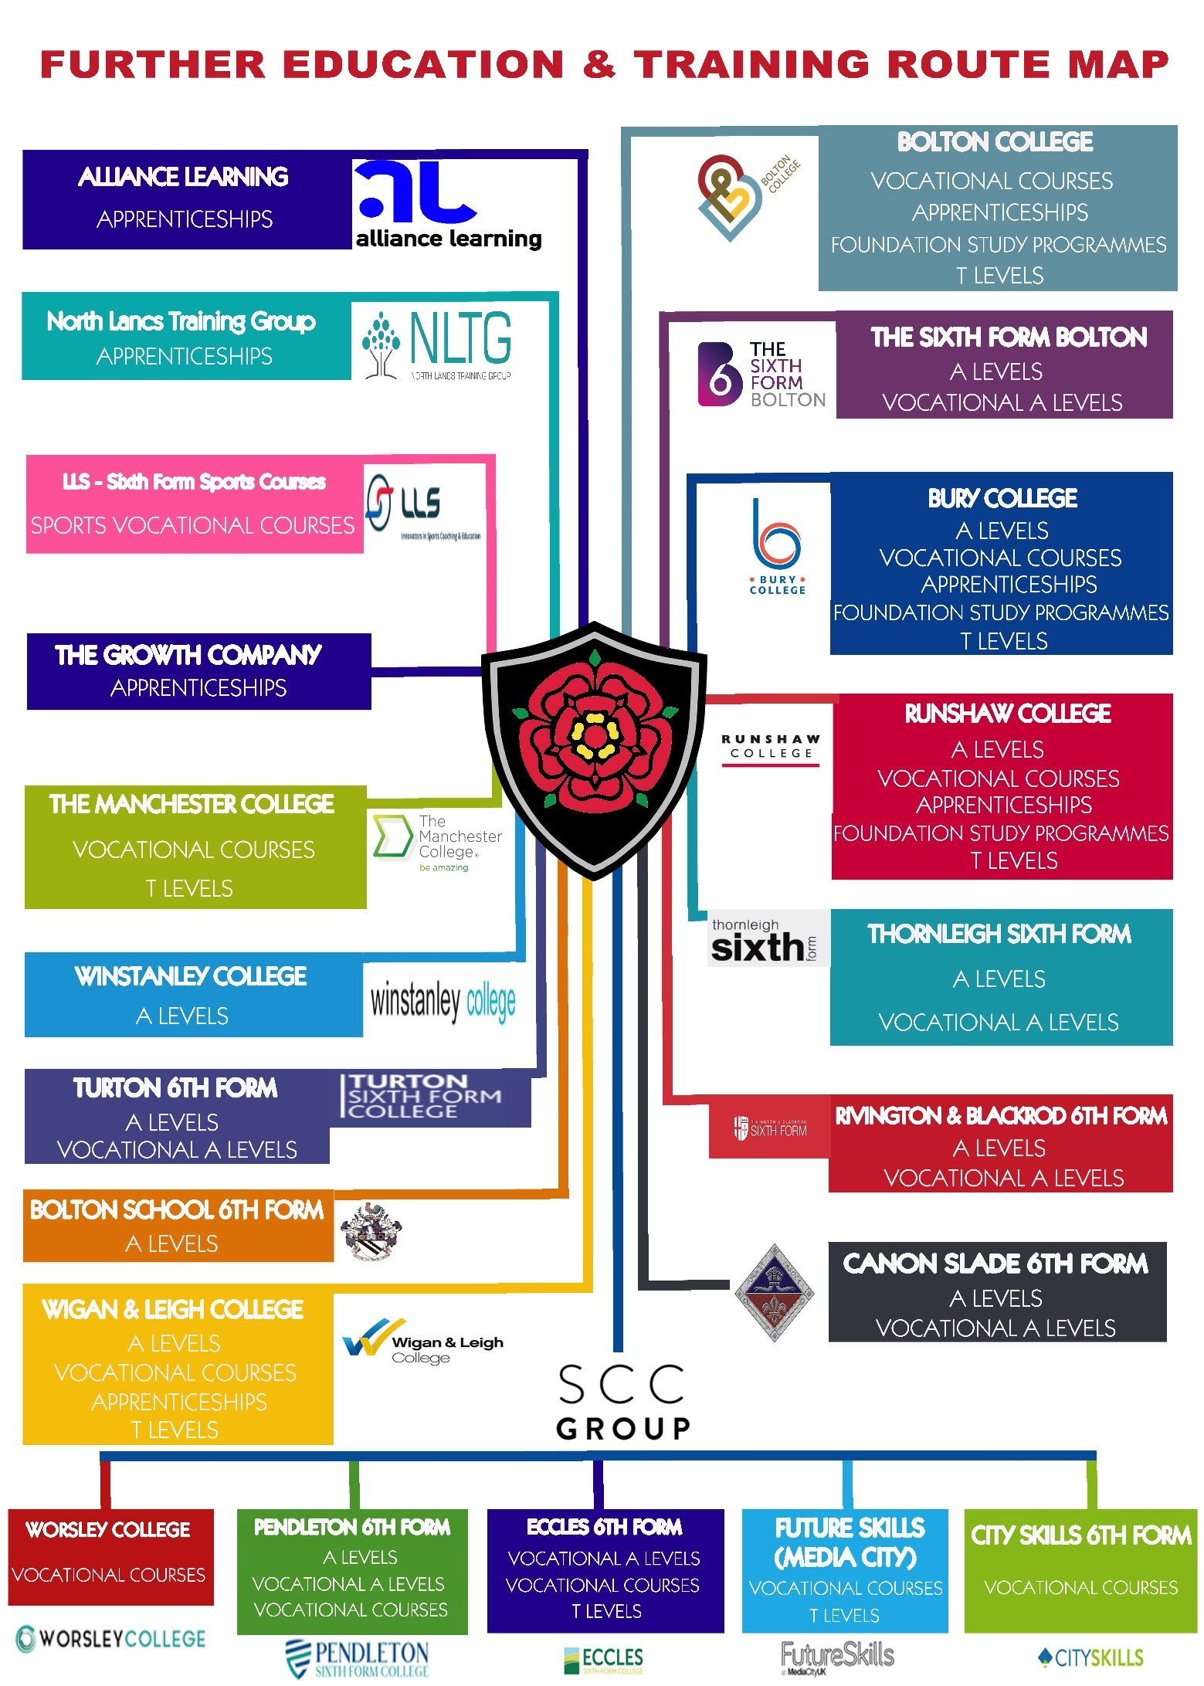

**Action Planning**

Have you ever completed an action plan that shows a clear route of where you see yourself in the future?

If you haven’t planned ahead then don’t be surprised if you don’t actually reach your intended destination. **Have a go at planning your own action plan.**

If you need more support to find out your progression route then go and visit the Careers Team in school or research yourself using the excellent websites available.

Some links are available on the school website under careers.

|  |  |
| --- | --- |
| What is your current academic achievement  (use predicted grades/levels ) | I am currently working at Level____  Level 1= GCSE Grades 3 and below  Level 2 = GCSE Grades 9-4 |
| What ROUTE might you be interested in pursuing Post 16? ( after Smithills) | * A Levels : Choice of 3/4 subjects (Level 3) * Vocational A Levels (Single award)   Choice of 3/4 subjects (Level 3)   * Vocational A Level (Triple award -sometimes referred to as BTEC L3 Extended Diploma) choose ONE subject area (Level 3) * An Apprenticeship (L2 intermediate/L3 advanced ) * BTEC or other vocational related qualifications (Level 1/2) * Foundation studies (Entry level) * ESOL/Foundation learning (Entry level) |
| What Subjects are you enjoying currently? | I currently enjoy |
| Subjects you feel you are doing well in? | I am doing well in |
| What Career aspirations have you for the future? |  |
| Do you intend to remain in full time education when leaving Smithills? |  |
| Are you interested in pursuing an Apprenticeship in the future perhaps?  (At 16? At 18?)  (In what area?) |  |
| Are you hoping to go to University?  Which ones might be future considerations? |  |
| Do you know what progression routes are available for you in your chosen career?  (School- Further education/apprenticeship – Higher education/ apprenticeship) | |
| What is needed to progress in your chosen Career/route? | |
| Research I could do? ( links available on school website – CAREERS page)   * Start Profile online resources to match your interests , skills and work preferences to potential Careers/ employment opportunities * Career Pilot ( requires no login to search jobs , pay, skills etc) * Websites of specific Post 16 colleges of interest to you * NHS Careers website * National Apprenticeship website * Other websites | |
| Open evenings (with dates) for those providers I would like to explore in more depth. | |
| Taster sessions/ careers events I could attend? | |
| Relevant Work Experience/ Volunteering | |

**QUALIFICATIONS**

You should be familiar with your academic ROUTE. However does this realistically reflect the grades you are likely to achieve by the end of Year 11? Are you continuing to progress at the rate expected of you?

Speak with your teachers regularly throughout the year to monitor your current assessment grades and see what progress you are making towards achieving your end of Y11 predicted grades.

***Task:***

1. Highlight the subjects you are currently studying ( or any you have studied and already gained a qualification)
2. Record your current assessment grade achieved, alongside your route or predicted grades.
3. Keep this for reference when completing predicted GCSE grades for your College applications.

|  |  |  |  |  |  |  |
| --- | --- | --- | --- | --- | --- | --- |
| **Subject** | **Current Assessment** | **Route/ predicted**  **GCSE Grade** |  | **Subject** | **Current Assessment** | **Route/ predicted**  **GCSE Grade** |
| **Art** |  |  |  | **Hair & Beauty** |  |  |
| **Art**  **(Technical Award Creative & Media)** |  |  |  | **Maths** |  |  |
| **Business Studies** |  |  |  | **Music** |  |  |
| **Child Development** |  |  |  | **PE (Cambridge National)** |  |  |
| **Computer Science** |  |  |  | **Performing Arts** |  |  |
| **Dance** |  |  |  | **Photography** |  |  |
| **Drama** |  |  |  | **Psychology** |  |  |
| **Design Technology** |  |  |  | **R.E** |  |  |
| **English Language** |  |  |  | **Science (Combined)** |  |  |
| **English Literature** |  |  |  | **Step up to ENGLISH** |  |  |
| **Enterprise** |  |  |  | **Separate Sciences Biology** |  |  |
| **Food Technology** |  |  |  | **Separate Sciences Chemistry** |  |  |
| **French** |  |  |  | **Separate Sciences Physics** |  |  |
| **German** |  |  |  | **Spanish** |  |  |
| **Geography** |  |  |  | **Travel & Tourism** |  |  |
| **History** |  |  |  | **Urdu** |  |  |

This will help you to understand which LEVEL of qualification you are most likely to progress onto when making post 16 choices and, depending on the subject area you have chosen to pursue, which qualification type you will be able to access considering both current attainment and predictions.

**Qualifications & Levels**

**Triple Vocational A Level**

**Single Vocational A Level**

**ESOL: Foundation Learning**

**Honours Programme**

**T Levels**

**Foundation Learning**

**A Levels**

**Btec L1 Diploma**

**Btec L2 Diploma**

When selecting subjects and courses you would like to pursue after Year 11, you need to know what types of qualification are available. You also need to appreciate what LEVEL you should be applying for when you apply for college/6th Form or an apprenticeship so you can make the correct selection and understand your progression route.

**Try to match the correct ‘Type of qualification’ with the correct description for ‘What qualifications do I need to be able to study at this level’**

Use the answers provided below and complete the table on the next page.

**What types of qualifications are available and what do I need to achieve to be able to study at each level?**

|  |  |  |
| --- | --- | --- |
| **LEVEL** | **Type of qualification** | **What qualifications do I need to be able to study at this level?** |
| Level 3 |  | A minimum of 5/6 GCSEs at grades 9-5/4 include Maths & English language.  Note: Some will ask for at least 2 subjects at grade 6 or above. (Some will require Combination of 3 GCSEs at Grade 5 and 3 GCSEs at grade 4- Please check individual providers as this changes every year!) |
| Btec Level 3 |  | A minimum of 5 GCSEs at grades 9-5/4 including Maths & English Language |
| Btec Level 3 | (equivalent to one A-level) This qualification is usually coursework assessed rather than a final examination | These qualifications are usually studied alongside A levels. The minimum requirements would be the same as A-levels. |
| Level 3 |  | This programme will be recommended for high flyers on achievement of many GCSEs at grade 9-7 including English & Maths |
| Level 3 |  | These are fairly NEW qualifications equivalent to three A Levels, 80% Class work, 20% Work Endorsed by business, they include a 45-day industry placement to help you learn what a real career is like. Entry requirement vary at different institutions but generally 5 GCSE Grades 9-4 including Maths & English (grade 9-4) |
| Level 2 |  | These courses are for students who have achieved GCSEs (grades 3-1) including Maths and English |
| Level 1 |  | These courses are for students who have achieved GCSEs at a minimum of grade 1/2 |
| Below Level 1 |  | This programme is recommended for students who have not achieved any formal qualifications on leaving school |
| Below Level 1 |  | This is a full-time course suitable for anyone who is a relatively new arrival in the UK and who does not yet have the level of English required to progress on to level 1 qualifications. |

[Traineeship Logo](http://www.apprenticeships.org.uk/traineeships.aspx)[](http://www.apprenticeships.org.uk/)

**APPRENTICESHIP OR TRAINEESHIP?**

**Which is Which?**

|  |  |
| --- | --- |
|  | A work-based training programme that combines on the job training with study. This means that you will earn a wage and work alongside experienced staff to gain job-specific skills.  You also train off the job, usually on a day-release basis at a local college or training provider, and work towards nationally recognised qualifications. |
|  | An **unwaged** education and training programme with work experience that is focused on giving you the **skills** **and** **experience that employers are looking for**. At its core are work preparation training, English and maths for those who need it, and a **high quality work experience placement**. |

**WHAT TYPE OF APPRENTICESHIPS COULD I DO?**

**Advanced Higher Intermediate**

* **1 - _______________________Level Apprenticeships**

Apprentices work towards work-based learning qualifications such as a Level 2 Competence Qualification, Functional Skills and, in most cases, a relevant knowledge-based qualification.

* **2 - ______________________Level Apprenticeships**

Apprentices work towards work-based learning such as a Level 3 Competence Qualification, Functional Skills and, in most cases, a relevant knowledge based qualification.

* **3 - ____________________________Apprenticeships**

Apprentices work towards work-based learning qualifications such as a Level 4 Competence Qualification, Functional Skills and, in some cases, a knowledge-based qualification such as a Foundation Degree.

**Examples of current Apprenticeship Opportunities**

* Accountancy
* Business Administration
* Beauty Therapy
* Catering & Hospitality
* Carpentry & Joinery
* Childcare
* Children’s Care, Learning and Development
* Creative and Media
* Construction Trades
* Customer Service
* Dental Nursing
* Domestic Heating
* Electrical Engineering
* Electrical Installation
* Fabrication Welding
* Gas Installation
* Hairdressing and Barbering
* Health & Social Care
* IT Professionals
* IT User
* Management
* Manufacturing
* Mechanical engineering
* Motor Vehicle
* Nail Services
* Painting & Decorating
* Play work
* Plastering
* Plumbing
* Roofing
* Retail
* Sports and Recreation
* Teaching Assistant
* Team Leading
* Travel Services

**Quick QUIZ**

**1. An Apprenticeship is for you if you…….**

a. would rather work than continue in full time education

b. would like to earn while you learn

c. have a specific job identified and are ready to work with an employer

**2. How many GCSEs do you need to get on an Apprenticeship?**

a. A minimum of 5 GCSE’s at grade 4 or above

b. GCSE Maths & English at Grade 4 or above

c. No GCSE’s

**3. At what age can you do an Apprenticeship?**

a. 16-24

b. 18 or over

c. Any age over 16

**4. How many hours per week will you be expected to work as a minimum on an Apprenticeship**

a. 25 Hours

b. 30 Hours

c. 50 Hours

**5. What is a training provider?**

a. A company that can improve your fitness

b. A company that will provide training as part of your apprenticeship

c. A company that will charge you for an Apprenticeship

**6. How could you apply for an Apprenticeship?**

a. By applying directly via a company website

b. By applying using UCAS

c. By applying using the National Apprenticeship Website

**7. How much do you get paid per hour as a minimum on an Apprenticeship?**

a. £4.51

b. £4.71

c. £4.81

**8. List at least 10 jobs or careers that could be studied as an Apprenticeship**

**1.**

**2.**

**3.**

**4.**

**5.**

**6.**

**7.**

**8.**

**9.**

**10.**

[](http://www.apprenticeships.org.uk/)**Summary Sheet**

**HOW LONG ARE APPRENTICESHIPS?**

Apprenticeships can take **between** **one and four** years to complete depending on the level of Apprenticeship, the apprentices’ ability and the industry sector. The minimum salary is **£4.81** per hour; however, many apprentices earn significantly more.

**Key benefits:**

* Earn a salary
* Get paid holidays
* Receive training
* Gain qualifications.
* Learn job-specific skills

**WHO ARE THEY FOR?**

Apprenticeships are open to all age groups above 16 years old. Competition for places with employers can be fierce, so you need to show that you are committed, and aware of the responsibilities to both yourself and the company who employs you.

**HOW DO I FIND OUT WHAT APPRENTICESHIPS ARE AVAILABLE TO ME AND WHERE?**

[**www.apprenticeships.gov.uk**](http://www.apprenticeships.gov.uk)

* Go to: [www.apprenticeships.gov.uk](http://www.apprenticeships.gov.uk)
* Click the ‘Create an account’ and fill in your details.
* Create a username and password. You will then receive a confirmation e-mail to activate your account.
* The link opens a window to a secure space ‘My home page’
* Now you may search for Apprenticeships that match your interests.
* Once you have found a suitable vacancy, complete the secure and reusable application form.

BE AWARE:

Some school leaver vacancies may not be posted until the spring/summer term

However many companies who run their own apprenticeship schemes have specific dates when their applications open. **Please check individual company websites carefully**.

**LOCAL TRAINING PROVIDERS OFFERING APPRENTICESHIPS.**

There are a wide range of providers throughout the North West offering apprenticeships in a variety of different work sectors. Further information is available from your Careers Team in school.

**RESEARCH: What Apprenticeship opportunities do they offer?**

|  |  |
| --- | --- |
| ALLIANCE LEARNING  www.alliancelearning.com |  |
| BOLTON COLLEGE  www.boltoncollege.ac.uk |  |
| BURY COLLEGE APPRENTICESHIPS  www.burycollege.ac.uk/apprenticeships |  |
| NORTH LANCS TRAINING GROUP  www.nltg.co.uk |  |
| The Growth Company  [**www.gceducationandskills.ac.uk**](http://www.gceducationandskills.ac.uk/) |  |

**There are also many large companies who offer apprenticeship and you should search these websites to find out more details about these opportunities.**

**Companies that provide Apprenticeship Schemes**

|  |  |
| --- | --- |
| Airbus  [www.airbus.com](http://www.airbus.com) |  |
| MBDA  [www.mbda-systems.com](http://www.mbda-systems.com) |  |
| BAE Systems  [www.baesystems.com](http://www.baesystems.com) |  |
| Seddon  [www.apprentices.seddon.co.uk](http://www.apprentices.seddon.co.uk) |  |
| Barclays <https://joinus.barclays/eme/apprenticeships> |  |
| NHS  <https://www.stepintothenhs.nhs.uk/apprenticeships> |  |
| ANS  <https://www.ans.co.uk/> |  |
| BBC  <https://www.bbc.co.uk/careers/trainee-schemes-and-apprenticeships> |  |

**It is advisable to search individual company websites for apprenticeship schemes available and email them to register your interest**

**Personal Statement**

**You may be required to complete a personal statement as part of your online application for Post 16 education or training**



**One step at a time**

**Supporting your Post 16 Transition**



**Writing a personal statement will take time.**

**It is helpful to break it down into manageable chunks.**

* **Use each questions to help structure your paragraphs and draft your personal statement.**
* **Type up each section as you go along and you will soon have a completed statement**

What is a Personal Statement?

* Whether you are applying for a further education course, a degree course at university or a job, you will be expected to complete a section of the application process called the ‘**Personal Statement’.**
* This is the blank space usually at the end of application forms, or as a free text box. It is your chance to say why you think you should be accepted onto the course.
* You may or may not be required to complete a personal statement as part of the application process this year.
* It can also be the most daunting part of completing an application form!
* You WILL need to know what course(s) you are applying for BEFORE completing your statement.

**Personal Statement**

**Get some words down on paper to get you started**

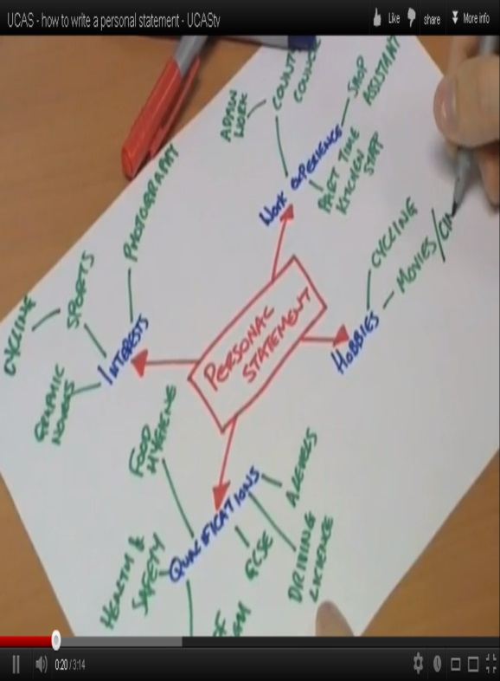

**Brainstorm your achievements, work experience, interests, skills, qualities and any other experiences you have had or projects and activities in which you’ve been involved.**

[](http://www.google.co.uk/url?sa=i&rct=j&q=time&source=images&cd=&cad=rja&uact=8&docid=3mX_wzBFhqmWSM&tbnid=Xx_NcjwzJyKIfM:&ved=0CAcQjRw&url=http://www.4castplus.com/time-phased-budgeting-who-needs-time-phased-budgeting/&ei=IFEyVPS6H9DcaNe5gPgH&bvm=bv.76802529,d.d2s&psig=AFQjCNHhYSTgKfXrkQYegqoVdovG_bUNMA&ust=1412669992427082)**Personal Statement**

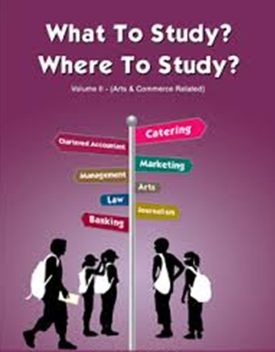

[](http://www.google.co.uk/url?sa=i&rct=j&q=college%20courses&source=images&cd=&cad=rja&uact=8&docid=FINd9fVmY53ejM&tbnid=fSpRPwXX70jHiM:&ved=0CAcQjRw&url=http://online.dpsk12.org/2013/02/16/take-college-classes-next-fall/&ei=mG0yVMXEFI2xPOS9gagH&bvm=bv.76802529,d.ZGU&psig=AFQjCNFuw19cX_hP4n0Tz3bPOXXq9xBsJQ&ust=1412677385107332)

[](http://www.google.co.uk/url?sa=i&rct=j&q=apprenticeship&source=images&cd=&cad=rja&uact=8&docid=DpotfAYTPw8b-M&tbnid=3QcvIfXGlTuT2M:&ved=0CAcQjRw&url=http://orangejuicepr.co.uk/?p%3D715&ei=2G0yVLONKsbWPZWVgJAC&bvm=bv.76802529,d.ZGU&psig=AFQjCNFU_WuTnRtStSW6ymAWxOzFfBHBhQ&ust=1412677438679931)

**If you haven’t decided which course(s) you want to pursue yet, just move onto the other sections and come back to the first section at a later date.**

**1. What subjects do you enjoy currently and what subjects would you like to study at College. (Is there a specific reason you want to apply for these courses?)**

|  |
| --- |
|  |

|  |
| --- |
| ***For example: I am currently in Year 11 at Smithills School. I have a particular interest in Art and Business. I have researched the options and routes available to me in pursuing these areas of study and would be very interested in studying for A Levels in Art & Business so that I can pursue a possible career in Marketing in the future. I spent my work experience in the marketing department of a local company and really enjoyed using my creative skills.*** |

**2. Tell me about YOU- include some of the following;**

* [](http://www.google.co.uk/url?sa=i&rct=j&q=knowledge%20and%20skills&source=images&cd=&cad=rja&uact=8&docid=rdjFrTASDytWTM&tbnid=7XMsvaEWHmh_sM:&ved=0CAcQjRw&url=http://freedomoutpost.com/2013/11/thing-skills-hands-knowledge-mind/&ei=QlYyVMqVBtfvatGCgrgH&bvm=bv.76802529,d.d2s&psig=AFQjCNGwHCy9h4B2hQtNwaVKGx5jMM2SCQ&ust=1412671398894194)Involvement in extracurricular activities and clubs / community / sports teams/ performing arts etc.
* What skills I have
* Any positions of responsibility
* Any hobbies and interests outside of school.
* Proud moments: achievements/awards
* Additional qualifications being studied or completed.
* Work experience

|  |
| --- |
|  |

***For example:***

|  |
| --- |
| ***I enjoy creative writing and debating different topics. I have been involved in Mock trials and represented Smithills in a regional competition presenting a case for the defence. I have been part of the school council where I have listened to my peers and represented them at meetings. I also enjoy solving problems and was part of the enterprise game challenge last year learning about business and how to take risk to generate profits. I am proud to be a peer mentor in school and supported younger pupils through difficult times. I have 100 % attendance certificates. I have recently been involved in the stalls in the hall enterprise challenge at school which helped raise money this year for the charity ‘Make Kyle Smile’***  ***Example 2***  ***I am involved in the Duke of Edinburgh Award scheme which has allowed me to develop leadership skills, self-discipline and teamwork. I have also been able to use my organisational skills as a helper at Bolton Lads and Girls Club and organise games and activities. I have completed a marketing project as part of my business studies course so understand how best to maximise sales. I have represented the school in an Enterprise challenge competition which required us to purchase stock and sell to maximise profits whilst also gaining distribution centres to improve the number of sales. I have taken on additional roles in school including being a sports leader which has enabled me to demonstrate that I can be responsible for others and take the lead in specific situations. I attend a local gym which helps me develop my fitness.*** |

[](http://www.google.co.uk/url?sa=i&rct=j&q=my%20future&source=images&cd=&cad=rja&uact=8&docid=iD9CSBkyMjvgfM&tbnid=HZvZPhonWxeElM:&ved=0CAcQjRw&url=http://borderlinebloggeren.blogspot.com/2012_09_01_archive.html&ei=-FwyVO65MYT7PP-ogbgF&bvm=bv.76802529,d.d2s&psig=AFQjCNGVll_gCP0wKdIdbSkkNZfghG1NsA&ust=1412672983547377)

**3. What I want to do after college. Long term aspirations –University/ Apprenticeship/ Employment.**

|  |
| --- |
|  |

***For example:***

|  |
| --- |
| ***I would very much like to remain in full time education and eventually go to university.***  ***I would love to pursue a career that permitted me to be creative and travel.***  ***Or***  ***I would very much like to pursue an apprenticeship route in the future and gain employment with one of the major companies in my chosen field.***  ***Or***  ***After completing my studies at college I would like to become employed as a….*** |

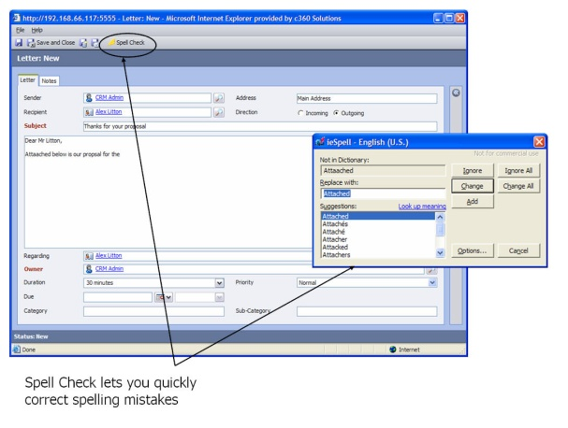

Before submitting your application

Check it!

Make sure;

* It is written in good, concise English
* There are no grammatical and spelling errors.
* It is not copied as this could jeopardise your applications to college.

[](http://www.google.co.uk/url?sa=i&rct=j&q=top+tip&source=images&cd=&cad=rja&uact=8&docid=eGJl2StPbnZZgM&tbnid=8gb_4AEBo5uufM:&ved=0CAcQjRw&url=http://www.whodoyouthinkyouaremagazine.com/next-steps/ancestors-overseas&ei=FmcyVMf9H4nGPeCTgHA&bvm=bv.76802529,d.ZGU&psig=AFQjCNEASG-DoBQdVJECqXVpOfB3bbjwPA&ust=1412675687236383) Make sure you have the course content and entry requirements to hand so you can refer to them as you are preparing your personal statement.



Return to your personal statement every time you make a new application, especially **if you are applying for a different course** or a number of subject areas. **Your reasons for wanting to study the course/subjects would be different. Save a different version of your personal statement.**



**ANSWERS**

**Qualifications & Levels**

|  |  |  |
| --- | --- | --- |
| **LEVEL** | **Type of qualification** | **What qualifications do I need to be able to study at this level?** |
| Level 3 | **A Levels** | A minimum of 5/6 GCSEs at grades 9-5/4 include Maths & English language.  Note: Some will ask for at least 2 subjects at grade 6 or above. (Some will require Combination of 3 GCSEs at Grade 5 and 3 GCSEs at grade 4- Please check individual providers as this changes every year!) |
| Btec Level 3 (Extended Diploma) | **Triple Vocational A Level** | A minimum of 5 GCSEs at grades 9-5/4 including Maths & English Language |
| Btec Level 3 | **Single Vocational A Level**  (equivalent to one A-level) This qualification is usually coursework and/or practically assessed rather than one final examination | These qualifications are usually studied alongside A levels. The minimum requirements would be the same as A-levels. |
| Level 3 | **Honours Programme** | This programme will be recommended for high flyers on achievement of many GCSEs at grade 9-7 including English & Maths |
| Level 3 | **T Levels** | These are fairly NEW qualifications equivalent to three A Levels, 80% Class work, 20% Work Endorsed by business, they include a 45-day industry placement to help you learn what a real career is like. Entry requirement vary at different institutions but generally 5 GCSE Grades 9-4 including Maths & English (grade 9-4) |
| Level 2 | **Btec L2 Diploma** | These courses are for students who have achieved GCSEs (grades 3-1) including Maths and English |
| Level 1 | **Btec L1 Diploma** | These courses are for students who have achieved GCSEs at a minimum of grade 1/2 |
| Below Level 1 | **Foundation Learning** | This programme is recommended for students who have not achieved any formal qualifications on leaving school |
| Below Level 1 | **ESOL: Foundation Learning** | This is a full-time course suitable for anyone who is a relatively new arrival in the UK and who does not yet have the level of English required to progress on to level 1 qualifications. |

[Traineeship Logo](http://www.apprenticeships.org.uk/traineeships.aspx)[](http://www.apprenticeships.org.uk/)

**APPRENTICESHIP OR TRAINEESHIP?**

**Which is Which?**

|  |  |
| --- | --- |
| **APPRENTICESHIP** | A work-based training programme that combines on the job training with study. This means that you will earn a wage and work alongside experienced staff to gain job-specific skills.  You also train off the job, usually on a day-release basis at a local college or training provider, and work towards nationally recognised qualifications. |
| **TRAINEESHIP** | An **unwaged** education and training programme with work experience that is focused on giving you the **skills** **and** **experience that employers are looking for**. At its core are work preparation training, English and maths for those who need it, and a **high quality work experience placement**. |

**WHAT TYPE OF APPRENTICESHIPS COULD I DO?**

* **1 – Intermediate Level Apprenticeships**

Apprentices work towards work-based learning qualifications such as a Level 2 Competence Qualification, Functional Skills and, in most cases, a relevant knowledge-based qualification.

* **2 - Advanced Level Apprenticeships**

Apprentices work towards work-based learning such as a Level 3 Competence Qualification, Functional Skills and, in most cases, a relevant knowledge based qualification.

* **3 – Higher Apprenticeships**

Apprentices work towards work-based learning qualifications such as a Level 4 Competence Qualification, Functional Skills and, in some cases, a knowledge-based qualification such as a Foundation Degree.

**Quick QUIZ**

**1. An Apprenticeship is for you if you…….**

a. would rather work than continue in full time education

b. would like to earn while you learn

c. have a specific job identified and are ready to work with an employer

**2. How many GCSEs do you need to get on an Apprenticeship?**

a. A minimum of 5 GCSE’s at grade 4 or above

b. GCSE Maths & English at Grade 4 or above

c. No GCSE’s

Note: All employers ask for different things but they ALL ask for a good standard of Maths & English to show you have the ability to be trained.

**3. At what age can you do an Apprenticeship?**

a. 16-24

b. 18 or over

c. Any age over 16

**4. How many hours per week will you be expected to work as a minimum on an Apprenticeship**

a. 25 Hours

b. 30 Hours

c. 50 Hours

**5. What is a training provider?**

a. A company that can improve your fitness

b. A company that will provide training as part of your apprenticeship

c. A company that will charge you for an Apprenticeship

**6. How could you apply for an Apprenticeship?**

a. By applying directly via a company website

b. By applying using UCAS

c. By applying using the National Apprenticeship Website

**Note: You will need BOTH a training provider and an employer to have successfully secured an apprenticeship.**

**7. How much do you get paid per hour as a minimum on an Apprenticeship?**

a. £4.51

b. £4.71

c. £4.81

**8. List at least 10 jobs or careers that could be studied as an Apprenticeship**

1. Business administration

2. Hairdressing / Barbering

3. Medical administration

4. Dental nursing

5. Children’s and young people’s workforce

6. Health & Social Care

7. Motor vehicle

8. Electrical and mechanical

9. Engineering maintenance

10. Animal Care

RESEARCH: LOCAL TRAINING PROVIDERS offering Apprenticeships

|  |  |
| --- | --- |
| ALLIANCE LEARNING  www.alliancelearning.com |  |
| BOLTON COLLEGE  www.boltoncollege.ac.uk | Business & professional services  Computing & IT  Construction  Early Years ( Child Care)  Floristry  Hairdressing & barbering  Health & Social Care  Motor vehicle  Sport, Fitness & Wellbeing  Teaching assistant |
| BURY COLLEGE APPRENTICESHIPS  www.burycollege.ac.uk/apprenticeships | Accounting & Finance  Business , Law & Economics  Childcare & Teaching  Customer service  Dental  Hair, Beauty & Barbering  Health & Social Care  Management and Administration |
| North Lancs Training Group  <https://www.nltg.co.uk/>  **​** | Business Administration  Catering and Hospitality  Customer Service  Furniture Occupations  Sewing & Upholstery  General Manufacturing  IT and Digital Marketing  Team leading and management  Warehouse & Logistics |
| The Growth Company  [**www.gceducationandskills.ac.uk**](http://www.gceducationandskills.ac.uk/) |  |

Companies that provide Apprenticeships

|  |  |
| --- | --- |
| Airbus  [www.airbus.com](http://www.airbus.com) | Engineering  Digital & Technology Solutions Business  Finance  Customer Services Engineering  Craft |
| MBDA  [www.mbda-systems.com](http://www.mbda-systems.com) | Engineering  Engineering & Operations  Business |
| BAE Systems  [www.baesystems.com](http://www.baesystems.com) | Engineering  Project management  IT  Manufacturing  Business administration  Cyber security |
| Seddon  [www.apprentices.seddon.co.uk](http://www.apprentices.seddon.co.uk) | [Painting and Decorating](http://www.seddongroup.co.uk/downloads/apprentice-painter-2018.pdf)  [Trainee Construction Technician](http://www.seddongroup.co.uk/downloads/trainee-construction-technician-2018.pdf)  [Carpentry and Joinery](http://www.seddongroup.co.uk/downloads/apprentice-joiner-2018.pdf)  [Plumbing](http://www.seddongroup.co.uk/downloads/apprentice-plumber-2018.pdf)  [Plastering](http://www.seddongroup.co.uk/downloads/apprentice-plasterer-2018.pdf)  [Bricklaying](http://www.seddongroup.co.uk/downloads/apprentice-bricklayer-2018.pdf) |
| Barclays <https://joinus.barclays/eme/apprenticeships> | Foundation  Higher  Technology |
| NHS  <https://www.stepintothenhs.nhs.uk/apprenticeships> | Business administration and human resources  Clinical support  Communications and marketing  Construction/estates services  Dental nursing  Electrical and engineering  Financial services  Health and social care  Healthcare science (including pathology support and decontamination science)  IT  Management  Pharmacy support |
| ANS  <https://www.ans.co.uk/> | Digital Marketing and Social Media  Infrastructure Technician  Maintenance  Networking  IT  Software Development  Events  Customer Service |
| BBC  https://www.bbc.co.uk/careers/trainee-schemes-and-apprenticeships | [Broadcast Operation](http://www.bbc.co.uk/careers/trainee-schemes-and-apprenticeships/technology/broadcast-operator), [Broadcast Engineer](http://www.bbc.co.uk/careers/trainee-schemes-and-apprenticeships/technology/techapprenticeship), [Business Management](http://www.bbc.co.uk/careers/trainee-schemes-and-apprenticeships/business-support/business-apprenticeship), [Software Engineering](http://www.bbc.co.uk/careers/trainee-schemes-and-apprenticeships/technology/software-engineering-degree-apprenticeship), [Journalism](http://www.bbc.co.uk/careers/trainee-schemes-and-apprenticeships/journalism/dja) and [Production](http://www.bbc.co.uk/careers/trainee-schemes-and-apprenticeships/production/production-apprentices), [Cyber Security](http://www.bbc.co.uk/careers/trainee-schemes-and-apprenticeships/technology/infosec) and [Research & Development](http://www.bbc.co.uk/careers/trainee-schemes-and-apprenticeships/technology/industrialtraineescheme) |